 | 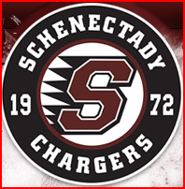 | 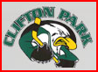 |  | 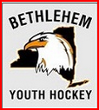

Please join the Capital Region Girls Alliance Program for

Girl’s Hockey “Night Out”

Friday, February 12, 2016 at 6:30pm, Clifton Park Arena

Girls will participate in a “Girls Only” ADM-style practice and small area games with other local players to meet new friends and enjoy a night of fun, hockey and pizza!!

